

OWASP JUICE SHOP

Unsigned JWT Token

Student ID:243700

Date: March 28th, 2026 Project: Unsigned JWT Token

Table of Contents

Contents
Student ID:243700 1
Table of Contents 2
Confidentiality Statement 4
Disclaimer 4
Contact Information 4
Assessment Overview 5
Assessment Components 5
Internal Penetration Test 5
Finding Severity Ratings 6
Risk Factors 6
Likelihood 6
Impact 6
Scope 7
Scope Exclusions 7
Client Allowances 7
Executive Summary 8
Scoping and Time Limitations 8
Testing Summary 8
Tester Notes and Recommendations 8
Vulnerability Summary & Report Card 9
Internal Penetration Test Findings 9
Technical Findings 10
Internal Penetration Test Findings 10
Steps to Reproduce 10
PoC (Screenshots & Scripts if Used) 12
Impact Analysis 12
Technical Findings 13
Internal Penetration Test Findings 13
Steps to Reproduce 13
PoC (Screenshots & Scripts if Used) 14
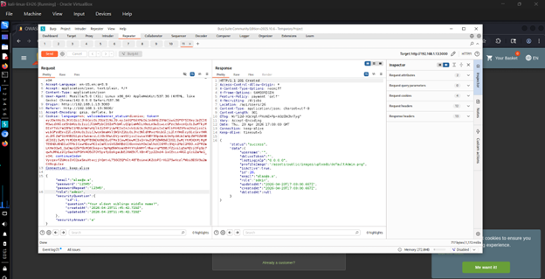 14
Impact Analysis: 14
PoC (Screenshots & Scripts if Used) 16
PoC (Screenshots & Scripts if Used) 18
PoC (Screenshots & Scripts if Used) 20

Confidentiality Statement

Disclaimer
This is a report for educational purposes, as part of a penetration test on the OWASP Juice Shop application. The tests were conducted in a controlled environment with permission and adherence to ethical standards.

The results outlined in this report reflect the state of the application at the time of testing, and are specific to the techniques and tools applied. Although every effort has been made to ensure the accuracy of this report, no warranty is given that all vulnerabilities have been found.

This report should not be used for malicious purposes. The information in this report must not be misused. The authors disclaim any liability or responsibility for the results of the use or misuse of this information.

The recommendations made are to enhance the security of the application and should be implemented following internal policies and guidelines.

Contact Information

Name | Contact Information
Abdelrahman Shehta | Email: abdelrahman243700@bue.edu.eg  ID: 243700

Assessment Overview
From September 22nd, 2025 to April 20th, 2026, BUE engaged to evaluate the security posture of OWASP JUICE SHOP to current industry best practices that included an internal network penetration test. All testing performed is based on the NIST SP 800-115 Technical Guide to Information Security Testing and Assessment, OWASP Testing Guide (v4), and customized testing frameworks.
Phases of penetration testing activities include the following:
- Planning – Customer goals are gathered and rules of engagement obtained.
- Discovery – Perform scanning and enumeration to identify potential vulnerabilities, weak areas, and exploits.
- Attack – Confirm potential vulnerabilities through exploitation and perform additional discovery upon new access.
- Reporting – Document all found vulnerabilities and exploits, failed attempts, and company strengths and weaknesses.
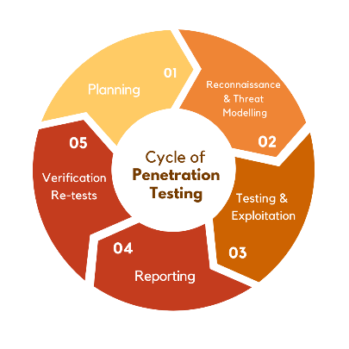

Assessment Components

Internal Penetration Test
An internal penetration test simulates the role of the attacker performing all possible attacks that he could find and also simulates the impact of how it could affect BUE

Finding Severity Ratings
The following table defines levels of severity and corresponding CVSS score range that are used throughout the document to assess vulnerability and risk impact.

Severity | CVSS V3  Score Range | Definition
Critical | 9.0-10.0 | Exploitation is straightforward and usually results in system-level compromise. It is advised to form a plan of action and patch immediately.
High | 7.0-8.9 | Exploitation is more difficult but could cause elevated privileges and potentially a loss of data or downtime. It is advised to form a plan of action and patch as soon as possible.
Medium | 4.0-6.9 | Vulnerabilities exist but are not exploitable or require extra steps such as social engineering. It is advised to form a plan of action and patch after high-priority issues have been resolved.
Low | 0.1-3.9 | Vulnerabilities are non-exploitable but would reduce an organization’s attack surface. It is advised to form a plan of action and patch during the next maintenance window.
Informational | N/A | No vulnerability exists. Additional information is provided regarding items noticed during testing, strong controls, and additional documentation.

Risk Factors
Risk is measured by two factors: Likelihood and Impact:

Likelihood
Likelihood measures the potential of a vulnerability being exploited. Ratings are given based on the difficulty of the attack, the available tools, attacker skill level, and client environment.

Impact
Impact measures the potential vulnerability’s effect on operations, including confidentiality, integrity, and availability of client systems and/or data, reputational harm, and financial loss.

Scope

Assessment | Details
Ex: Internal Penetration Test | Ex: 192.168.1.13/24

Scope Exclusions
Upon request, BUE did not perform any of the following attacks during testing:
- Denial of Service (DoS)
- Phishing/Social Engineering

All other attacks not specified above were permitted by BUE.

Client Allowances
BUE provided the following allowances:

- Internal access to OWASP JUICE SHOP

Executive Summary
This report is about the results of a security assessment done on OWASP juice shop web application.
The objective was to identify the vulnerabilities in the web application and evaluate it.
The assessment revealed that there are multiple vulnerabilities of different levels such as critical (Unsigned JWT token) as well as high and medium-risk flaws affecting application integrity and functionality.
It is recommended that the identified vulnerabilities be addressed and solved.

Scoping and Time Limitations
The penetration testing was performed in a lab environment on the OWASP Juice Shop application. The tests only focused on application-level vulnerabilities and not network-based attacks. The testing was conducted for a short time duration and was aimed at discovering common web application vulnerabilities manually and semi-automatically.
The following activities were out of scope:
Denial of Service (DoS) attacks Phishing or social engineering attacks Testing was conducted with permission and in an ethical manner.

Testing Summary

The penetration test involved a systematic approach of reconnaissance, vulnerability identification, exploitation and reporting.

Tools like Burp Suite and browser developer tools were employed to intercept and modify HTTP requests, detect vulnerabilities and confirm security issues.

Our testing revealed several vulnerabilities, including critical authentication and authorization weaknesses and high
severity input validation vulnerabilities.

Tester Notes and Recommendations

The assessment mentioned several security weaknesses related to a weakness in the server-side validation and improper access control mechanisms

It is recommended that the application add more strict input validation, enforce proper authentication and authorization controls and follow secure coding methods.

Vulnerability Summary & Report Card
The following tables illustrate the vulnerabilities found by impact and recommended remediations:

Internal Penetration Test Findings

*No. of CriticalFound* | *No. of HIGH Found* | *No. of Medium Found* | *No. of Low Found* | *No. of Informational Found*
2 | 3 | 0 | 0 | 0

Finding | Severity | Recommendation
Unsigned JWT Token | Critical | Enforce JWT signature validation
Admin Registration | Critical | Restrict role assignment server-side
Upload Type Bypass | High | Validate file type and content server-side
Extra Language | High | Restrict unsupported inputs
Forged Review | High | Validate user identity server-side

Technical Findings

Internal Penetration Test Findings
Finding unsigned JWT Token (Critical)
Description: | The application accepts unsigned JWT tokens which can be manipulated to add a nonexisting user or even increase privileges
Risk: | This allows complete authentication bypass and privilege escalation. It severely impacts confidentiality and integrity.
System effected: | Authentication, Authorization.
Tools Used: | Burp Suite, JWT.io
References: | Jwt.io

Steps to Reproduce
- Log in and capture a JWT token
- Decode the token
- Modify header to "alg": "none"
- Change payload role to admin and the username to a nonexisting user
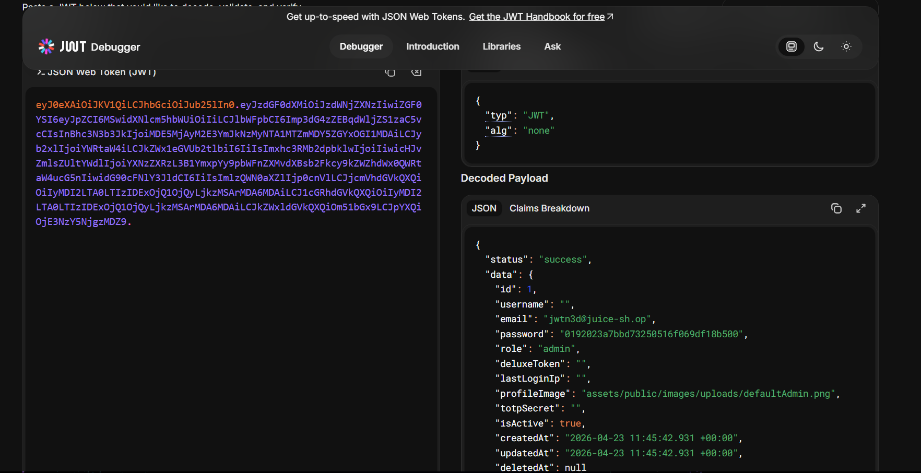
- Remove Signature
- Send modified token
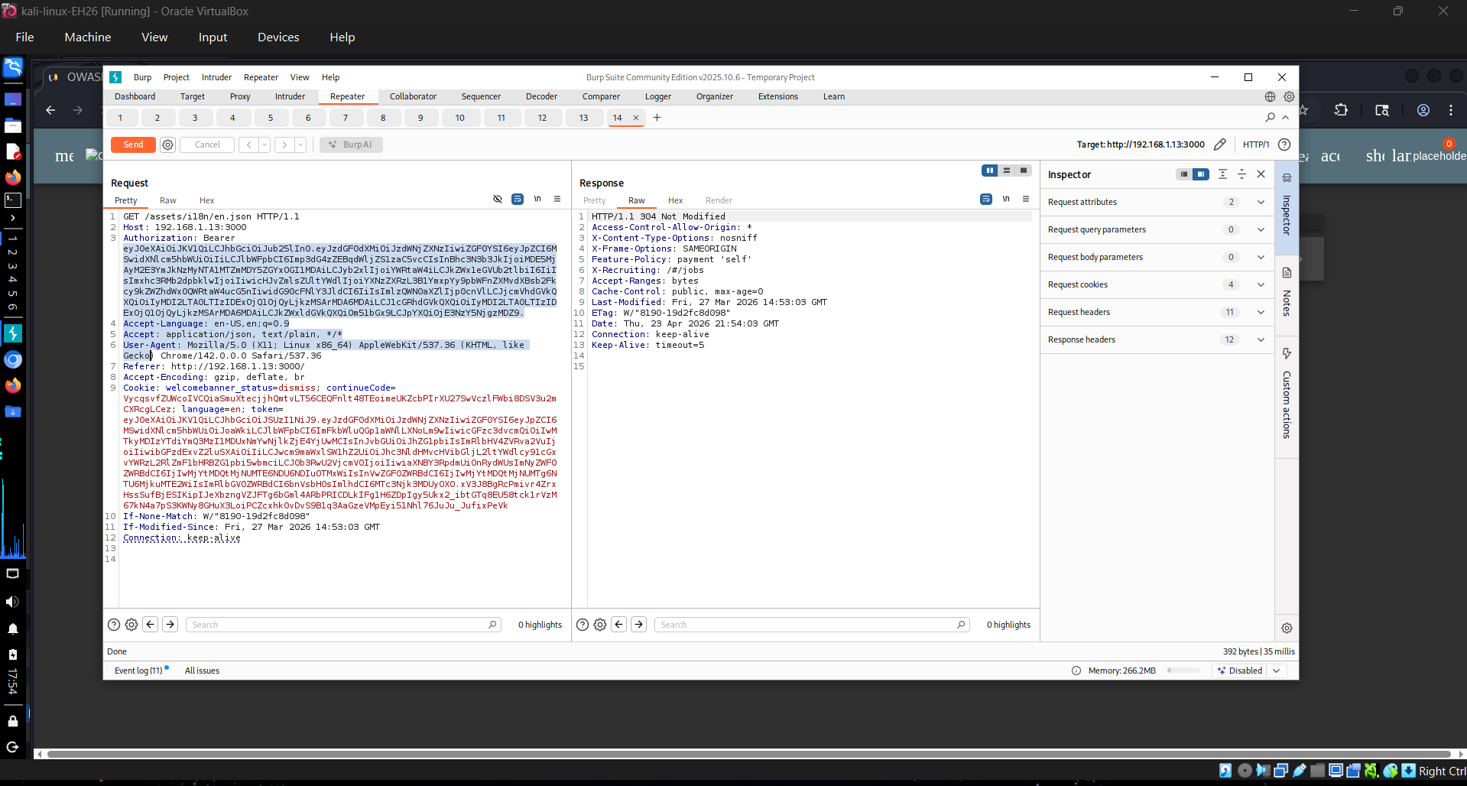

PoC (Screenshots & Scripts if Used)

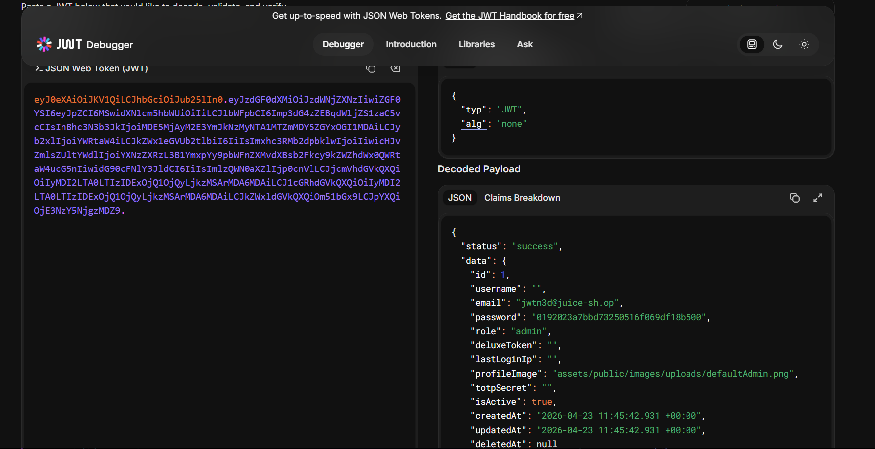

Impact Analysis
Successful exploitation of this vulnerability has the following consequences:
- Critical — Attackers can gain full administrative access, modify data, and control the system

Remediation:

- Reject “none” algorithm
- Enforce secure signing (HS256)
- Validate token signature server-side

Severity calculation:

CVSS Score = (Likelihood + Impact) / 2 × 2

Likelihood | Impact | Score
5 | 5 | 10

Technical Findings

Internal Penetration Test Findings
Finding Admin Registration (Critical)
Description: | User roles are not validated server-side, allowing attackers to assign themselves administrative privileges during registration using Burp suite.
Risk: | This Leads to full system compromise.
System effected: | User registration system
Tools Used: | Burp Suite
References: | Burp Suite

Steps to Reproduce
- Intercept Registration Request using burpsuite
- Add role admin
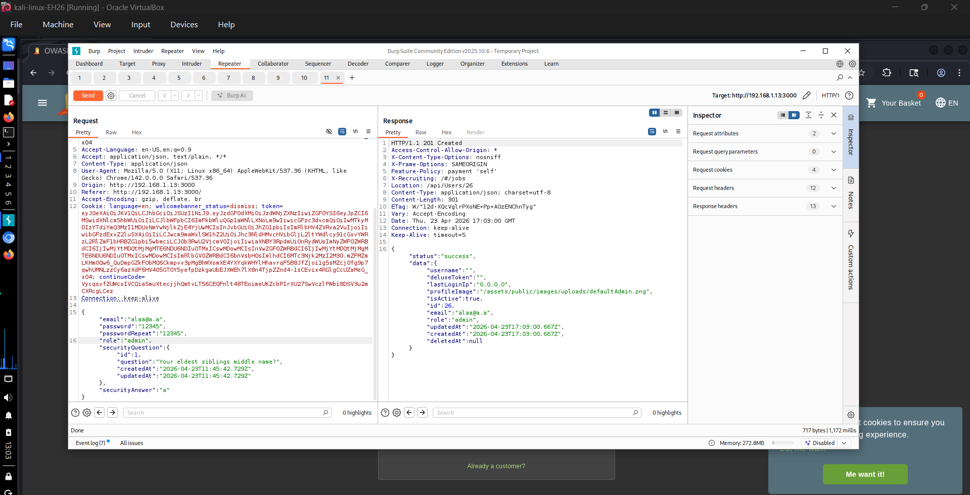
- Submit the request

PoC (Screenshots & Scripts if Used)



Impact Analysis:

- Full administrative control
- Data manipulation
Remediation:

- Enforce server-side role validation
- Remove role field from client input

Severity calculation:

CVSS Score = (Likelihood + Impact) / 2 × 2

Likelihood | Impact | Score
4 | 5 | 9.0

Finding Upload Type Bypass (High)
Description: | The application relies on client-side validation for file uploads, allowing attackers to bypass restrictions.
Risk: | Potential for malicious file upload and system compromise.
System effected: | File upload functionality
Tools Used: | Burp Suite
References: | Burp Suite

Steps to Reproduce:

- Intercept upload request
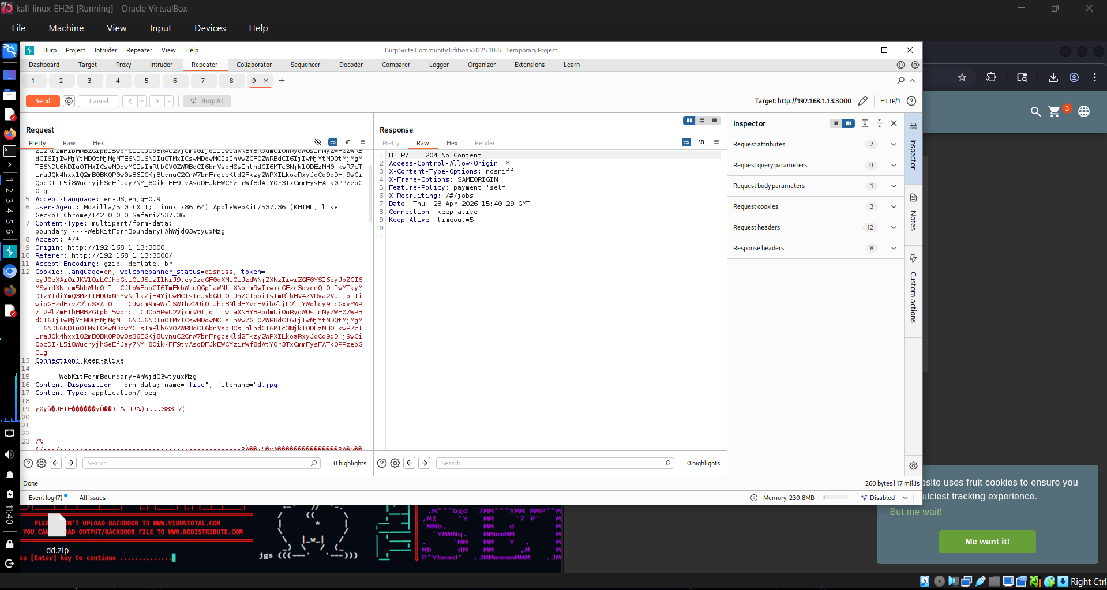
- Modify file type by adding the content of a jpg file
- Submit request

PoC (Screenshots & Scripts if Used)



Impact Analysis

- Possible remote code execution
- Malicious file storage

Remediation

- Validate file types of server-side
- Inspect file content
- Implement file scanning

Likelihood | Impact | Score
4 | 4 | 8.0

Finding Extra Language (High)
Description: | The application does not restrict unsupported language parameters, allowing access to hidden functionality.
Risk: | Exposure of hidden features and increased attack surface.
System effected: | Language handling system
Tools Used: | Burp Suite
References: | Burp Suite

Steps to Reproduce
- Intercept request
- Modify language parameter
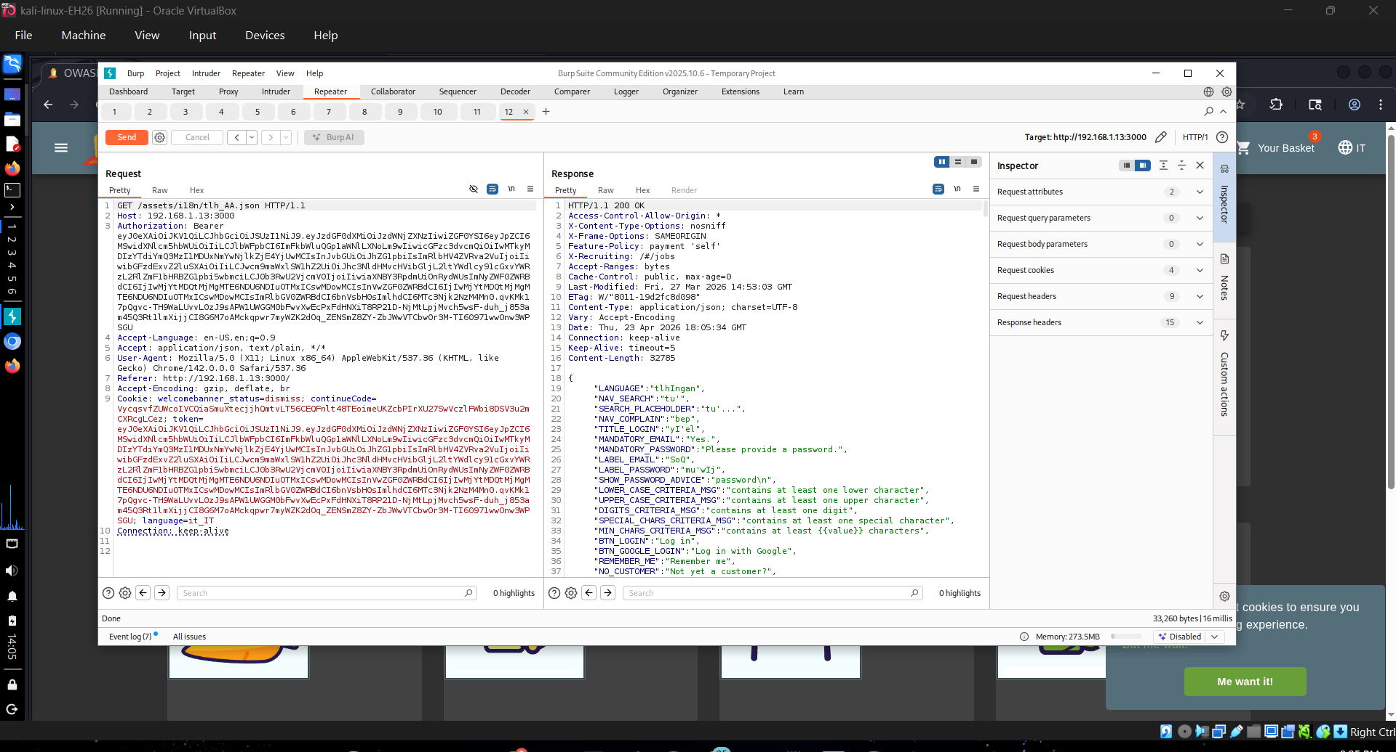
- Send request

PoC (Screenshots & Scripts if Used)

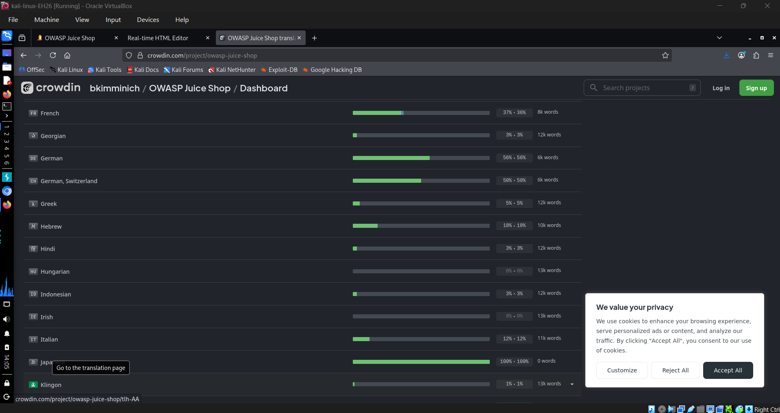

Impact Analysis

- Information disclosure
- Potential for further attacks

Remediation

- Validate input server-side
- Restrict allowed values

Likelihood | Impact | Score
5 | 3 | 8.0

Finding Forged Review (High)
Description: | The application does not validate the identity of the review author, allowing impersonation.
Risk: | Compromises data integrity.
System effected: | Review system
Tools Used: | Burp Suite
References: | Burp Suite

Steps to Reproduce

- Submit review
- Intercept request
- Modify author field

PoC (Screenshots & Scripts if Used)

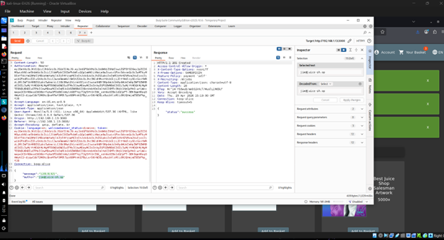

Impact Analysis
- User impersonation
- Loss of trust

Remediation
- Validate user identity server-side
- Use session-based authentication

Likelihood | Impact | Score
5 | 2 | 7.0



Last Page

